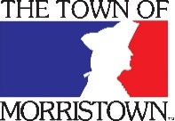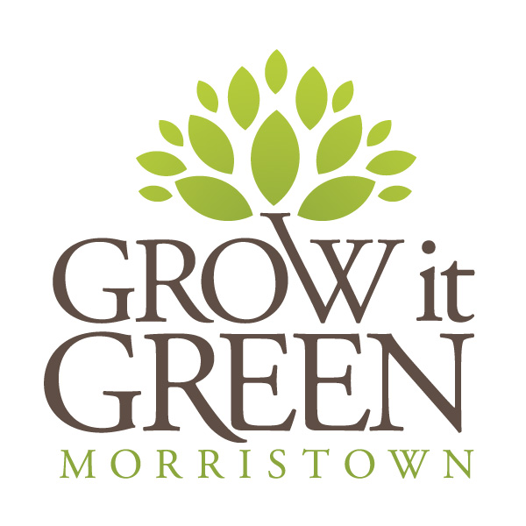

MEDIA RELEASE

FOR IMMEDIATE RELEASE: January 12, 2015

Contact:
Abby Gallo, 973-206-4177, abby@growitgreenmorristown.org

Morristown Awarded Sustainable Jersey Grant
$35,000 Provided to Fund Early Street Community Garden Solar Pavilion

Morristown, NJ (January 12, 2015) – Sustainable Jersey representatives announced that Morristown has been awarded a Sustainable Jersey Small Grant. Morristown is one of just three municipalities in New Jersey to receive a Sustainable Jersey Small Grant at the $35,000 level. The Sustainable Jersey Small Grants Program funded by the Gardinier Environmental Fund provides grants to local governments for sustainability projects. Sustainable Jersey distributed nearly $1.6 million in grants in the last five years, to help towns make their communities more livable, environmentally friendly and prosperous and now as a recipient, Morristown will build a solar-powered classroom pavilion that will be a focal point of Grow It Green Morristown’s rebuild of the Early Street Community Garden.

Using sustainable materials and natural systems, the energy created by the solar panels on the pavilion will provide the necessary energy for all uses of the community garden, including running a pump for the cistern, outlets for movie nights, bands and outdoor classes. The rain catchment system will provide the majority of water needed for gardening.

“Morristown is thrilled to receive this funding for the solar-powered pavilion at the Early Street Community Garden,” said Mayor Timothy Dougherty. “I applaud Grow It Green for their tireless efforts – the Early Street Community Garden has become a place where people reconnect both with nature and with each other. It has been wonderful to see a group of volunteers come together and transform an abandoned lot into a permanently preserved open space that will forever serve the people of Morristown. This new solar powered pavilion will now elevate an already unique and special place into a model of sustainability for community gardens across the country.”

As a temporary space for residents to grow their own vegetables, flowers and herbs, the garden was established and is managed by Grow It Green Morristown, a local nonprofit organization that seeks to be a “catalyst for positive change in the greater Morristown Community." Since its inception in 2009, a littered vacant lot has grown to serve over 50 families with garden plots and hosts countless others at community events including bike-in-movie nights, pot luck dinners, and a wide variety of educational programs. “The new solar powered pavilion marks a new phase of the Garden’s development by enabling new programming opportunities while also serving as a highly visible model of green technology,” says Grow It Green Morristown’s Executive Director Abby Gallo.

Morristown, the seat of Morris County, is a historic community that over the past decade has experienced renewed interest as the desirability of classic, walkable downtowns has grown around the county. At 2.8 square miles in size, Morristown is a regional destination for cultural activities, entertainment and is home to a number of corporations. Open space preservation is a core element of the Town’s growth strategy - the Town contains approximately 160 acres of permanently preserved land and thousands of acres in immediately surrounding communities. Morristown has an established commitment to sustainable growth policies and management practices, many of which are detailed in “Morristown Moving Forward”, the Town’s 2014 master plan. In recognition of these commitments, Morristown was recently awarded Bronze Certification for 2015 by Sustainable Jersey.

Website: townofmorristown.org
growitgreenmorristown.org

Facebook: http://www.facebook.com/townofmorristown
http://www.facebook.com/GrowItGreenMorristown

###

